Step1.

Perpare data for working :Intergation Pig To Bbase

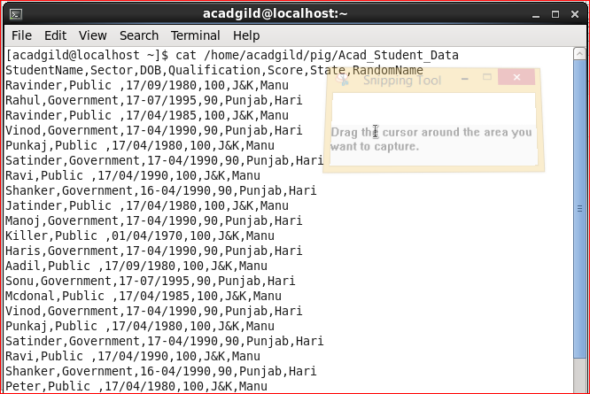

Step2.

Load Data using PigStorage.

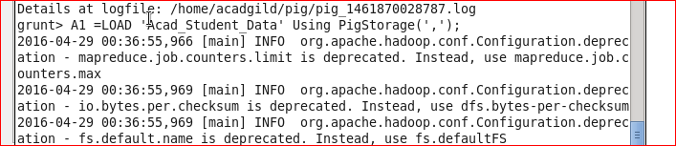

Step3.

Start Start-hbase.sh

Hbase shell

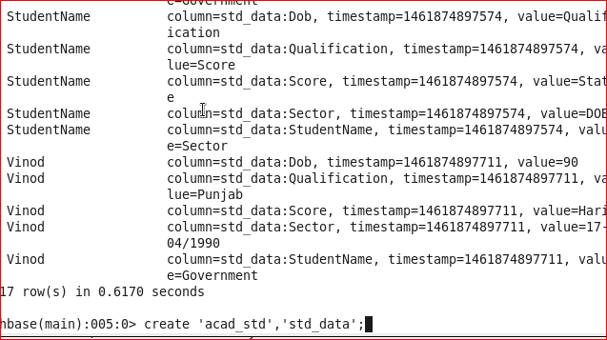

Step 3.

Store Pig output data to Hbase.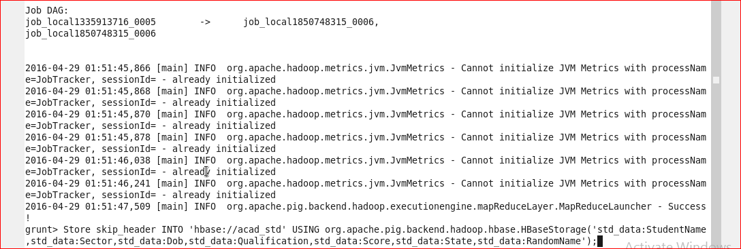

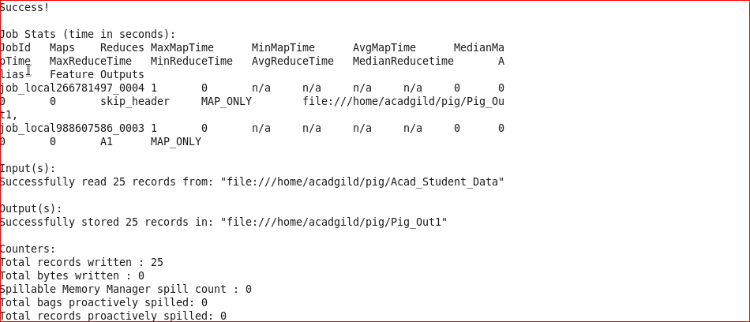

Step 4:

Scan hbase data.

